University Timetable Optimization and Management System
(UTOS)
Software Engineering Project Document
Full-Scope Analysis: Requirements, Use Cases, and System Modeling
Version 2.0 | May 2026

1. Introduction

1.1 Purpose
This document is the Software Engineering project report for the University Timetable Optimization and Management System (UTOS). It serves as the primary analytical and design record for a university-level SE course submission, covering requirements specification, use case analysis, system modeling, and implementation evidence.
UTOS is a web-based platform that automates, optimizes, and manages timetable creation for both weekly class schedules and semester examination periods at full university scale. The system handles the complexity arising from multiple departments, thousands of concurrent users, and a large set of hard and soft scheduling constraints.

1.2 System Overview
UTOS provides two closely related but operationally distinct scheduling subsystems within a unified platform:
- Class Timetabling Module -- weekly class schedule generation, conflict resolution, quality review, manual adjustment, locking, re-optimization, versioning, and publication.
- Exam Timetabling Module -- examination room management, student hierarchy, exam course association, semi-automatic exam placement, invigilation duty assignment, and exam schedule export.

Both modules share master data (rooms, users, roles, academic terms) and system-wide features including role-based access control, in-app notifications, version comparison, export (PDF/Excel/CSV), audit logging, and a comprehensive reporting suite.

1.3 Problem Statement
Manual timetable creation at university scale is a combinatorial problem of considerable complexity. The specific challenges addressed by UTOS include:
- Class Timetabling: Teacher clashes, room conflicts, section scheduling across dozens of departments, holiday handling, variable class durations (1 h, 1.5 h, 2 h), hundreds of hard and soft constraints, and thousands of enrolled students.
- Exam Timetabling: Multiple exam courses, large student populations, room capacity constraints, varied exam durations, no student double-booking, and invigilation assignment.
UTOS must handle these constraints at full university scale while remaining responsive, usable, and role-appropriate for six distinct user types.

1.4 Document Scope and Organization
This document is organized as follows:
- Introduction and Scope Alignment
- Process Model
- Requirements Summary
- Use Case Analysis -- High-Level, Essential, and Real Use Cases
- System Modeling -- DFDs, Swimlane, Sequence, ERD, and Architecture
- UI Evidence and Implementation Screens
- Traceability Matrix
- Conclusion and Document Checklist

1.5 Terminology and Conventions
Term | Definition
SuD | System under Discussion -- the UTOS web application (frontend, backend API, database, solver, notifications)
Timetable Administrator | Role with full access to timetable setup, generation, review, and publication
Department Coordinator | Role with department-level review, data validation, and change-request approval
Teacher | Role with view and change-request submission access
Student | Role with published timetable view only
Facility Manager | Role with room data maintenance and utilization report access
System Administrator | Role with user account, role, and security management access
Essential Use Case | Abstract, technology-free description of what the actor wants to achieve and why
Real Use Case | Concrete description of current UTOS interface behavior tied to UI screenshots
Hard Constraint | A scheduling rule that must never be violated (e.g., no teacher clash)
Soft Preference | A configurable optimization goal that the solver attempts to satisfy where possible

2. Process Model

2.1 Selected Lifecycle
UTOS uses the Incremental Process Model as its primary development lifecycle, supported by Prototyping for user interface validation. The incremental model was chosen because:
- The system is large and can be meaningfully divided into independently deliverable increments.
- Early increments (master data, constraints, basic generation) can produce a working product that stakeholders review while later increments add exam scheduling, reporting, and scale.
- Risk is reduced because hard problems (solver correctness, constraint logic) are addressed in early increments before the more complex exam and scale features are added.
- UI prototyping allows teachers and students to validate interface designs before backend features are complete.

2.2 Planned Increments
Increment | Module | Focus | User-Visible Value
1 | All | Master data + Academic Calendar | Admin can maintain teachers, rooms, sections, courses, timeslots, semester dates, and holidays.
2 | Class | Hard constraints + basic generation | System enforces no teacher, room, or section clashes; produces a draft timetable.
3 | Class | Soft preferences + quality scoring | Admin configures morning preference, early-end, energy-saving, room proximity, and views quality score.
4 | Class | Review + manual adjustment + locking | Admin inspects, fixes, and locks entries; constraint validation runs on every edit.
5 | Class | Re-optimization + versioning | Approved changes trigger solver repair with locked entries preserved; version history maintained.
6 | Class | Publish + role views | Teachers and students view published schedules filtered to their role and identity.
7 | Exam | Room management + student hierarchy | Exam module foundations: room capacity/type and University to Batch to Section to Student tree.
8 | Exam | Exam scheduling | System suggests exam sessions; admin confirms; no student is double-booked.
9 | System | Background jobs + scale | Long-running generation runs non-blocking; system handles 1000+ concurrent users.
10 | All | Polish + integration | Final integration, UI consistency, export, notifications, audit logs, and reports.

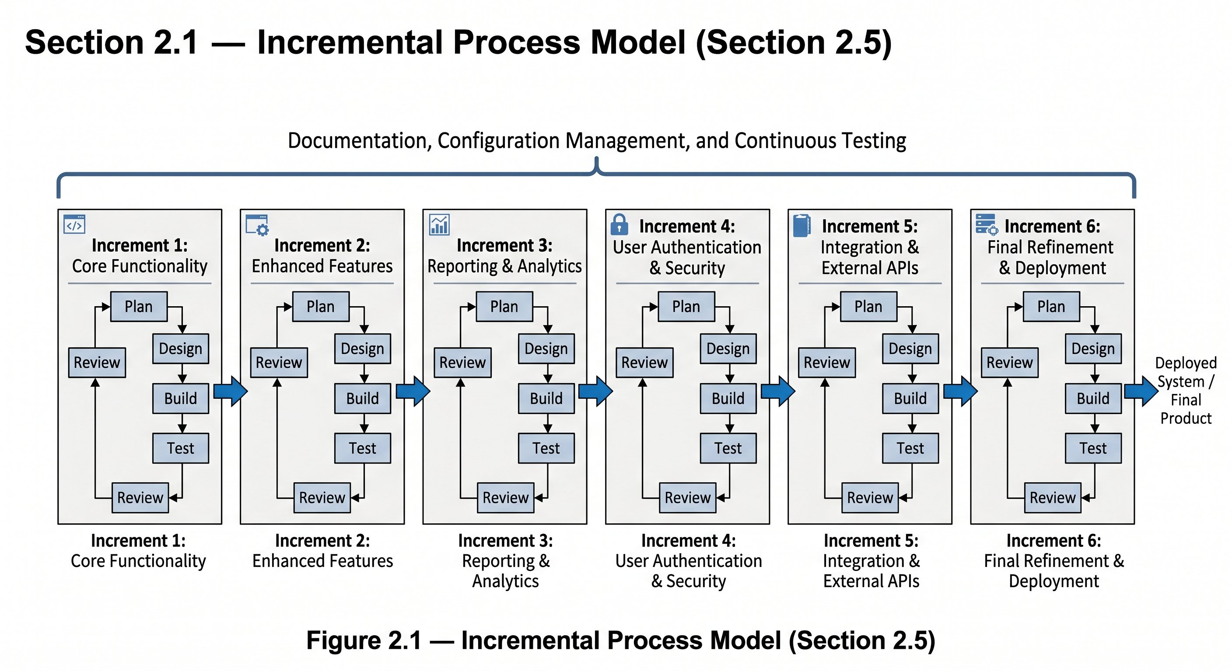
Figure 2.1 -- Incremental Process Model showing six increments (Core Functionality through Final Refinement and Deployment) with Plan, Design, Build, Test, and Review phases inside each increment.

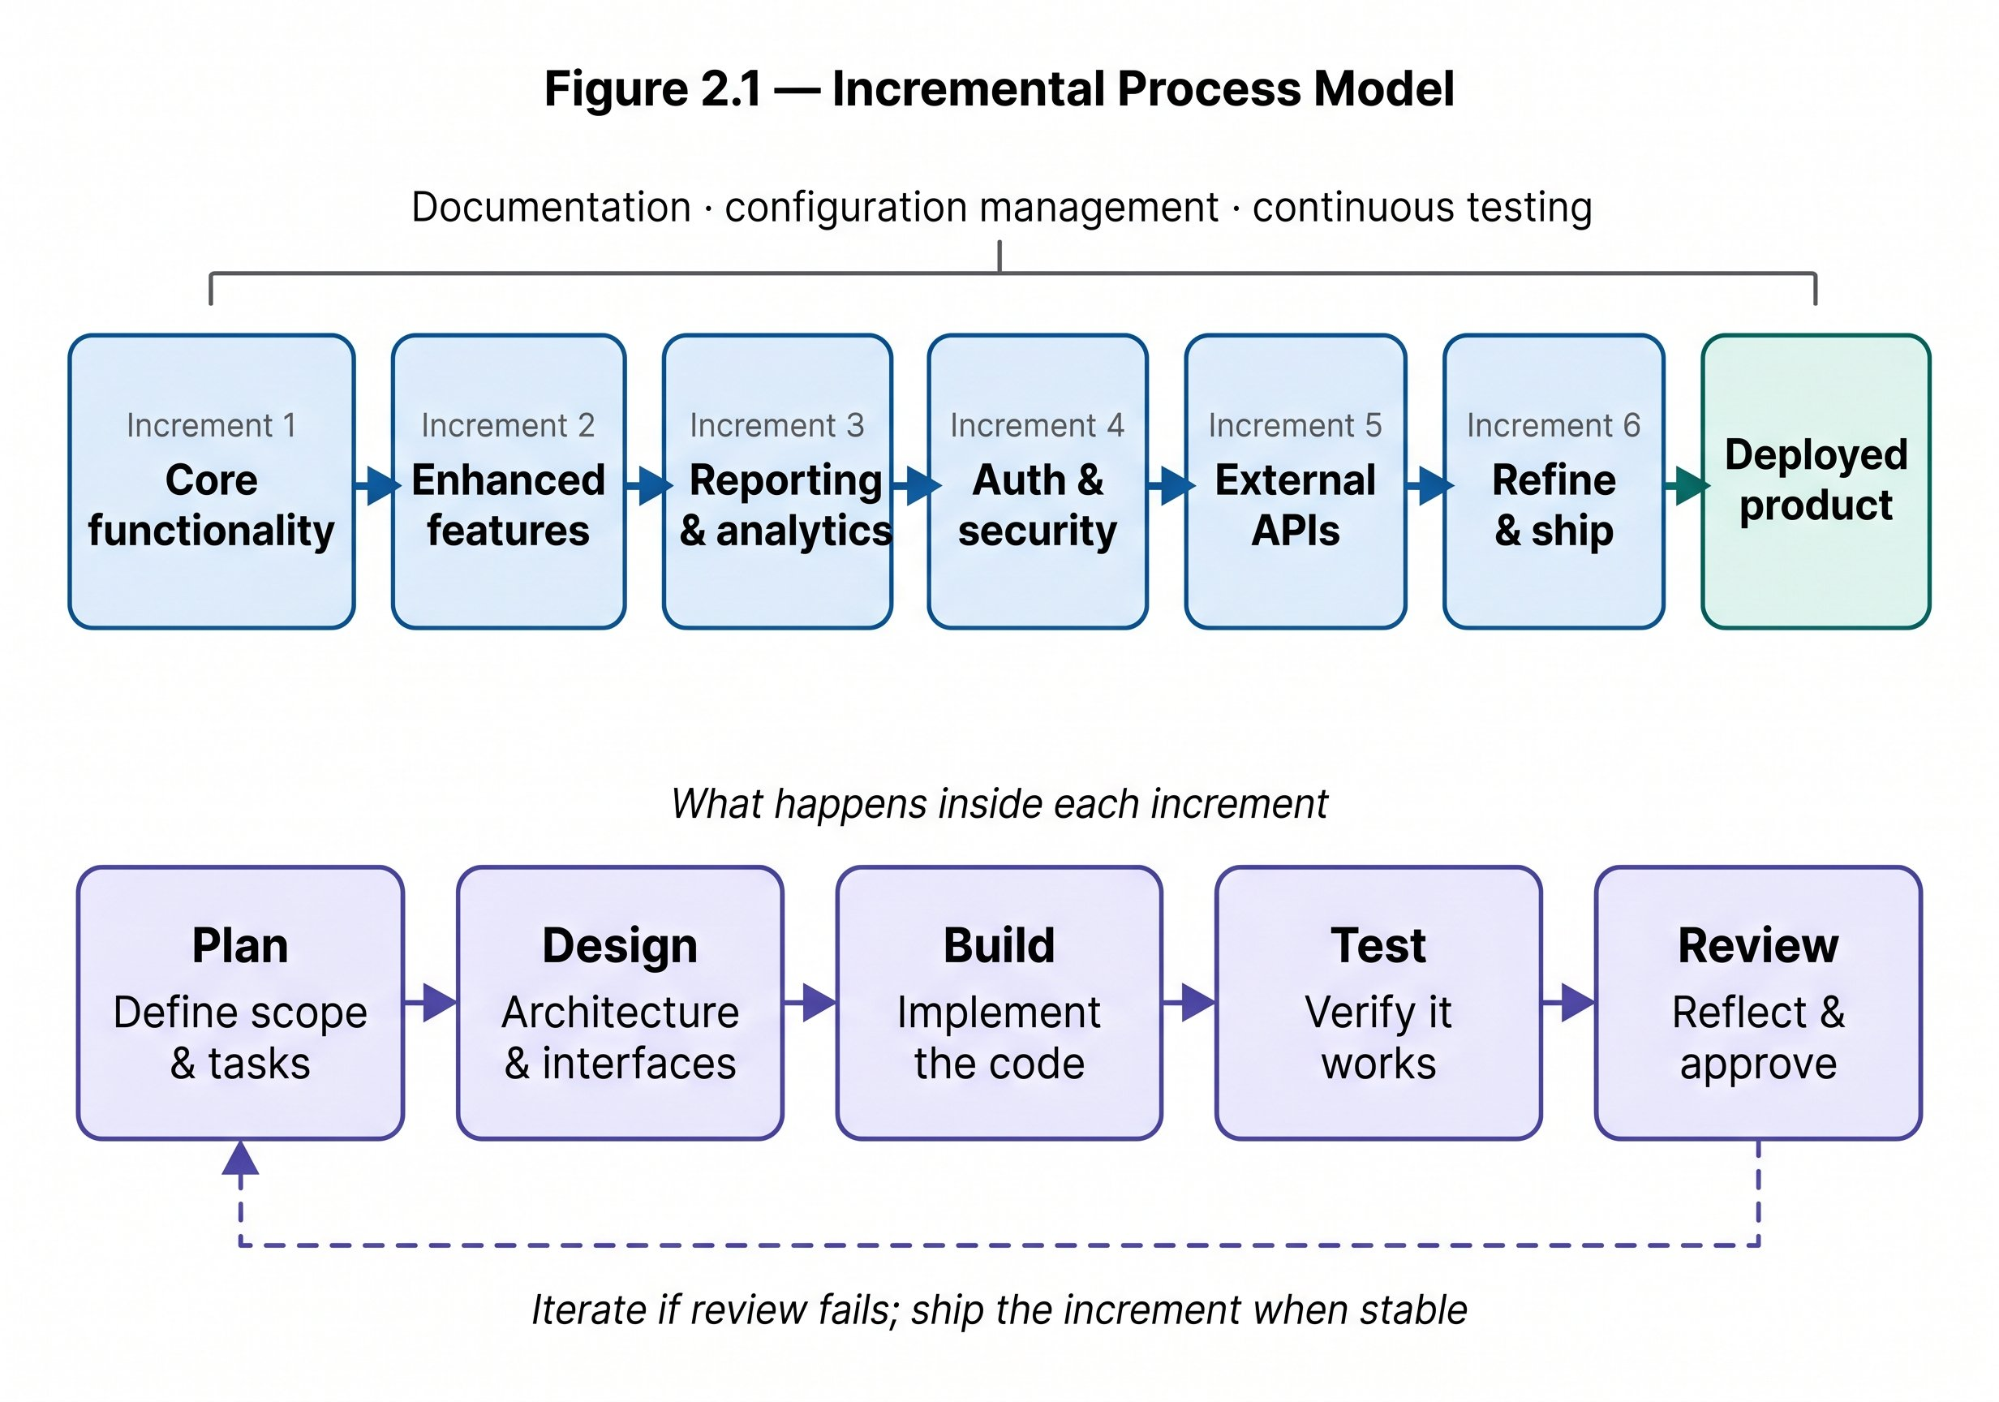
Figure 2.2 -- Incremental Process Model detail showing inner-increment phases: Plan (define scope and tasks), Design (architecture and interfaces), Build (implement the code), Test (verify it works), and Review (reflect and approve). Dashed arrow indicates iteration if review fails.

3. Requirements Summary
Requirements are drawn directly from SRS v1.0 Full Scope and summarized here so that use cases and diagrams can cross-reference them by number.

3.1 User Roles and Actors
Role | Login Method | Core Responsibilities
Timetable Administrator | Role selection + password | Full access: setup, generation, review, locking, publishing, versioning, reporting.
Department Coordinator | Email + password | Department data validation, review, change-request approval, quality review.
Teacher | Email + password | View personal timetable, set availability, submit change requests.
Student | Email + password | View published section timetable and exam schedule.
Facility Manager | Email + password | Maintain room data, view room utilization reports.
System Administrator | Email + password | User accounts, roles, security, audit logs, backup configuration.

3.2 Functional Requirements by Module

MODULE 0 -- System-Wide Features
Requirement Group | Key Requirements
Authentication and Login | FR-00.1 Admin login by role+password; FR-00.2 others by email+password; FR-00.4 session in localStorage; FR-00.5 session persistence; FR-00.6 logout and password reset.
Organization Hierarchy | FR-00.6a University-Faculty-Department; FR-00.6b Batch-Section; FR-00.6c academic terms; FR-00.6d per-term timetable versions.
Export | FR-00.1 PDF (A4); FR-00.2 Excel; FR-00.3 CSV; FR-00.4 all columns included.
Notifications | FR-00.6--FR-00.14: generation complete, publish, change-request status, approve/reject, lock/unlock, new version; unread count badge; notification history.
Version Comparison | FR-00.15--FR-00.19: side-by-side view; added (green), removed (red), changed (yellow) highlights; summary counts.

MODULE 1 -- Class Timetabling
Requirement Group | Key Requirements
Academic Calendar | FR-01.1--FR-01.5: semester start/end dates; holidays; blackout dates; makeup classes.
Master Data | FR-02.1--FR-02.6b: teachers with max_daily_load; rooms with capacity, type, features; sections; courses with duration (1h/1.5h/2h); 15-minute breaks.
Constraints and Preferences | FR-03.1--FR-03.15: seven hard constraints (no teacher/room/section clash, capacity, lab rooms, holidays, availability); eight soft preferences (morning, early-end, proximity, energy-saving, traffic, 2-hour class options, holiday maximization).
Generation | FR-04.1--FR-04.7c: complete draft generation; hard constraint enforcement; soft optimization; unplaced sessions with reasons; background non-blocking execution.
Review and Quality | FR-05.1--FR-05.5: weekly grid view; hard conflict display; soft penalty breakdown; room utilization; teacher load per day.
Manual Adjustment and Locking | FR-06.1--FR-06.4: manual entry adjustment with constraint validation; lock/unlock entries; locked entries fixed in re-optimization.
Re-optimization | FR-07.1--FR-07.3: repair after approved changes; minimize disruption; locked entries unchanged.
Publication | FR-08.1--FR-08.4b: both coordinator and admin must approve; single published timetable per term; max 10 draft versions; auto-archive beyond 10.
Personal Views | FR-09.1--FR-09.3: teacher weekly view; student section view; course, room, time, teacher details shown.
Change Requests | FR-10.1--FR-10.3: teacher submission with optional reason; coordinator review; approved requests trigger re-optimization.

MODULE 3 -- Exam Timetabling
Requirement Group | Key Requirements
Exam Rooms | FR-15.1--FR-15.4: room capacity; room types (classroom, lab, conference, group study); reuse of class-timetable room data.
Student Hierarchy | FR-16.1--FR-16.4: University-Faculty-Department-Batch-Section-Student tree; bulk import from Excel/CSV.
Exam Courses | FR-17.1--FR-17.3: course-to-exam association; exam durations (1h, 2h, 3h); course-to-section links.
Exam Scheduling | FR-18.1--FR-18.8: system suggestions; admin confirm/modify; no student double-booking; room capacity check; 9:00 AM start; 15-minute check-in time.
Exam Views | FR-19.1--FR-19.5: student exam schedule; teacher invigilation duties; facility manager room usage; PDF and Excel export.

MODULE 4 -- System Administration
Requirement Group | Key Requirements
User Management | FR-20.1--FR-20.8: create accounts; assign roles; RBAC enforcement; teacher/student self-registration with email verification; bulk Excel/CSV import.
System Reports | FR-21.1--FR-21.8: room utilization; teacher load (daily/weekly); conflict summaries; audit logs; late-class report; energy usage; quality score breakdown; section load report.

3.3 Non-Functional Requirements Summary
Category | Key Requirements
Performance | Page load < 1 s; API response < 1 s; timetable generation 5--30 min (background); 1000+ concurrent users.
Security | Role-based access control; input validation; audit logging; session management.
Usability | Weekly grid with time-slot columns and day columns; color-coded courses; conflict warnings in plain language; progress indicators; notification badge; side-by-side version comparison.
Availability | Published timetable always accessible; version control for drafts; database backup capability.
Maintainability | Modular architecture; swappable solver interface; independent module configurations.

4. Use Case Analysis

4.1 Analysis Approach
Use cases in this document follow the approach described in the teacher-provided Analysis Models guidance (Larman / Jacobson methodology):
- Use cases are defined from actor goals, not from database tables or UI pages.
- High-level use cases provide a brief, structured overview of all major functional goals.
- Expanded use cases are fully dressed with purpose, overview, type, cross-references, typical course of events, and alternative courses.
- Essential use cases remain abstract and technology-free -- they describe what the actor needs and why, independent of UI or implementation.
- Real use cases describe the current UTOS interface behavior, connected to specific UI screenshots.
- Use case diagrams show actor-use case associations only. Business ordering is described in text and workflow diagrams, not forced into UML include/extend relationships.

4.2 Actors, Goals, and System Boundary
Actor | Type | Goal and Responsibility
Timetable Administrator | Primary | Full access to timetable setup, generation, review, repair, publishing, versioning, and reporting.
Department Coordinator | Primary / Supporting | Validates department-level data, reviews timetable quality, approves or rejects change requests.
Teacher | Primary | Views personal teaching timetable, sets availability, and submits change requests.
Student | Primary | Views the published section timetable and exam schedule.
Facility Manager | Supporting | Maintains room records, monitors room availability, and reviews room utilization reports.
System Administrator | Primary | Manages user accounts, role permissions, security configuration, and audit log access.

4.3 High-Level Use Case Summary
ID | Use Case Name | Module | Primary Actor | Essential Goal
UC00 | Authenticate and Login | System-wide | All users | Select role, enter credentials, and establish a session.
UC01 | Maintain Organization Hierarchy | System-wide | Timetable Administrator | Define university, faculty, department, batch, section, and academic term structure.
UC02 | Maintain Academic Calendar | Class Timetabling | Timetable Administrator | Define semester dates, holidays, blackout dates, and makeup-class windows.
UC03 | Manage Master Data | Class Timetabling | Timetable Administrator | Maintain teachers, rooms, courses, sections, timeslots, room types, capacity, and facilities.
UC04 | Define Constraints and Preferences | Class Timetabling | Timetable Administrator | Configure hard constraints and weighted soft preferences before generation.
UC05 | Generate Class Timetable | Class Timetabling | Timetable Administrator | Create a draft weekly timetable satisfying hard rules and optimizing soft goals.
UC06 | Review Timetable Quality | Class Timetabling | Timetable Administrator / Coordinator | Inspect conflicts, warnings, unplaced classes, quality score, and teacher load.
UC07 | Manually Adjust and Lock Timetable | Class Timetabling | Timetable Administrator | Move timetable entries manually and protect selected entries from solver changes.
UC08 | Submit Change Request | Class Timetabling | Teacher / Coordinator | Request a schedule change through a structured workflow.
UC09 | Approve or Reject Change Request | Class Timetabling | Department Coordinator / Admin | Review request details, run conflict check, and decide whether the change is accepted.
UC10 | Re-optimize Timetable | Class Timetabling | Timetable Administrator | Repair the timetable after approved changes while minimizing disruption.
UC11 | Publish Timetable | Class Timetabling | Timetable Administrator | Release the approved timetable as the official live schedule for the term.
UC12 | View Personal or Section Timetable | Class Timetabling | Teacher / Student | View the published timetable filtered to the user's role and identity.
UC13 | Export Timetable | System-wide | Timetable Administrator | Export timetable data to PDF, Excel, or CSV for external use or printing.
UC14 | Manage Notifications | System-wide | System / All users | Notify users when generation completes, timetable is published, or requests change status.
UC15 | Compare Timetable Versions | System-wide | Timetable Administrator | Compare two timetable versions side-by-side and identify added, removed, and changed entries.
UC16 | Manage Exam Rooms | Exam Timetabling | Timetable Administrator / Facility Manager | Maintain exam room capacity, room type, and availability for exam scheduling.
UC17 | Manage Student Hierarchy | Exam Timetabling | Timetable Administrator | Maintain University-Faculty-Department-Batch-Section-Student data.
UC18 | Manage Exam Courses | Exam Timetabling | Timetable Administrator | Associate courses with exams, set exam durations, and link to taking sections.
UC19 | Schedule Exams | Exam Timetabling | Timetable Administrator | Generate or suggest exam placements while preventing student and room conflicts.
UC20 | View Exam Schedule and Invigilation Duties | Exam Timetabling | Student / Teacher / Facility Manager | View exam schedule or invigilation duties filtered to the user's role.
UC21 | Manage Users and Roles | Administration | System Administrator | Create and maintain user accounts, assign roles, and control system access.
UC22 | View System Reports and Audit Logs | Administration | Timetable Administrator / Facility Manager / System Administrator | Access operational reports and a complete change audit trail.

4.4 Expanded Use Cases
The following expanded use cases are provided for the most important and complex user goals. Each use case includes both an essential flow (abstract, technology-free) and a real flow (concrete, tied to UTOS screens).

UC00 -- Authenticate and Login
Use Case ID | UC00
Use Case Name | Authenticate and Login
Scope | System-wide
Level | User goal
Primary Actor | All users (Timetable Administrator, Department Coordinator, Teacher, Student, Facility Manager, System Administrator)
Supporting Actors | None
Type | Primary, Essential and Real
Stakeholders and Interests | All users require reliable, role-appropriate authentication before accessing any system function.
Preconditions | The user possesses valid credentials. The UTOS web application is accessible.
Postconditions | A session is established in browser localStorage. The user is redirected to a role-appropriate dashboard.
Purpose | Verify identity, establish an authorized session, and route the user to their role-specific interface.
Overview | The login page presents a role-selection control. The Timetable Administrator logs in by selecting the Admin role and entering a password. All other users enter their registered email address and password. On success, a session token is stored and the user reaches their dashboard.
Cross References (SRS) | FR-00.1, FR-00.2, FR-00.4, FR-00.5, FR-00.6

Essential Use Case -- Typical Course of Events
# | Actor Action | System Response
1 | This use case begins when a user opens the UTOS application and is presented with a login interface.
2 |  | The system displays a single login page with a role-selection control and credential fields.
3 | The user selects their role and enters credentials.
4 |  | The system validates credentials against stored user records.
5 | The user submits the login form.
6 |  | The system creates a session, stores it for persistence, and redirects the user to their role-specific dashboard.
7 | The user navigates the system using role-appropriate features.
8 |  | The system enforces role-based access control on every request.

Real Use Case -- Current UTOS Interface Behavior
# | Actor Action | System Response
1 | This use case begins when the user opens the UTOS URL in a browser.
2 |  | The UI renders a single login page with a role dropdown and credential fields.
3 | The Timetable Administrator selects the Admin role and enters the administrator password. Other users select their role, enter email address, and enter password.
4 |  | The system submits credentials to the backend API and returns a session token.
5 | The user is redirected to the dashboard.
6 |  | The UI stores the session in localStorage and renders a role-specific sidebar.
7 | The user selects Log Out from the navigation menu.
8 |  | The system clears the session from localStorage and redirects to the login page.

Alternative Courses
Line | Alternative / Exception
4a | Credentials are invalid. The system displays a generic error message without specifying whether the username or password was incorrect.
4b | The account is inactive or suspended. The system displays a message directing the user to contact the System Administrator.
6a | The session expires due to inactivity (non-administrator roles). The system silently clears the session and redirects to the login page with an expiry notice.
6b | The user clicks "Forgot Password." The system sends a password-reset link to the registered email address.

Special Requirements
- Session must persist across browser refresh (FR-00.5). Administrator sessions do not expire on inactivity (FR-00.5b). Non-administrator sessions auto-expire on inactivity (FR-00.5a).

Related UI Screenshots
Figure 6.1 -- Role-selection login screen. The single-page design shows the role dropdown above the credential fields.
Figure 6.2 -- Role-specific sidebars after login, showing distinct navigation for each user role.

UC05 -- Generate Class Timetable
Use Case ID | UC05
Use Case Name | Generate Class Timetable
Scope | Class Timetabling
Level | User goal
Primary Actor | Timetable Administrator
Supporting Actors | Solver Engine (internal component)
Type | Primary, Essential and Real
Stakeholders and Interests | Timetable Administrator: needs a clash-free, optimized draft to review and publish. Department Coordinator: needs a timetable that respects department preferences. Teachers and Students: ultimately depend on a well-structured published timetable.
Preconditions | An active academic term has been configured. Teachers, rooms, sections, courses, and timeslots have been entered. Hard constraints and soft preferences have been configured.
Postconditions | A new draft timetable version is saved with all placed sessions and a list of any unplaced sessions with reasons. A quality score is calculated. The administrator is notified that generation is complete.
Purpose | Produce a complete weekly class timetable draft that satisfies all hard constraints and optimizes the configured soft preferences.
Overview | The administrator initiates generation from the Schedule Control Center. The system validates that master data is complete, then passes the problem to the solver. Generation runs in the background so the administrator can continue using other parts of the system.
Cross References (SRS) | FR-04.1 to FR-04.7c, FR-00.9

Essential Use Case -- Typical Course of Events
# | Actor Action | System Response
1 | This use case begins when the administrator decides to create a new class timetable draft for the current academic term.
2 |  | The system validates that all required master data is present: teachers, rooms, sections, courses, timeslots, and academic calendar.
3 | The administrator initiates timetable generation.
4 |  | The system starts the scheduling solver and returns control to the administrator immediately (background processing).
5 | The administrator monitors generation progress.
6 |  | The system shows a progress indicator. When complete, it saves the draft, calculates a quality score, identifies any unplaced sessions, and notifies the administrator.

Real Use Case -- Current UTOS Interface Behavior
# | Actor Action | System Response
1 | This use case begins when the administrator opens the Schedule Control Center.
2 |  | The UI displays system status cards (courses configured, rooms available, active sections, generation status) and a Generate Draft button.
3 | The administrator clicks Generate Draft.
4 |  | The backend validates master data completeness. If data is complete, the solver is started as a background job and a "Generation in progress" indicator appears in the UI.
5 | The administrator continues using other system areas while generation runs.
6 |  | The UI polls generation status. When the solver finishes, the UI shows "Generation complete" and the in-app notification bell updates.
7 | The administrator opens the generated draft.
8 |  | The UI renders the draft timetable in a weekly grid view with time-slot columns (08:30--16:00) and day columns (Monday--Friday).

Alternative Courses
Line | Alternative / Exception
2a | Master data is incomplete (missing teacher, room, section, course, or timeslot). The system lists the missing items and stops generation before starting the solver.
6a | No complete timetable is feasible. The system saves the partial result and lists every unplaced session with the specific constraint that blocked placement.
6c | Generation exceeds the maximum allowed time. The system saves whatever has been placed, marks the draft as partial, and notifies the administrator.

Special Requirements
- Generation must not block the UI (FR-04.6). The quality score must include a penalty breakdown by constraint type (FR-04.5).

Related UI Screenshots
Figure 6.3 -- Schedule Control Center dashboard showing system status cards and the Generate Draft entry point.

UC06 -- Review Timetable Quality
Use Case ID | UC06
Use Case Name | Review Timetable Quality
Scope | Class Timetabling
Level | User goal
Primary Actor | Timetable Administrator
Supporting Actors | Department Coordinator, Facility Manager
Type | Primary, Essential and Real
Stakeholders and Interests | Timetable Administrator: needs actionable quality information. Department Coordinator: needs to verify department-specific assignments. Facility Manager: needs to check room utilization.
Preconditions | A draft timetable version exists (generated via UC05).
Postconditions | The administrator has enough information to proceed to manual adjustment (UC07), re-optimization (UC10), or publish (UC11).
Purpose | Evaluate whether the generated draft is feasible, acceptable, and efficient before committing it for publication.
Overview | The system presents the weekly timetable grid alongside conflict cards, quality score, penalty breakdown, room utilization statistics, and teacher load data.
Cross References (SRS) | FR-05.1, FR-05.2, FR-05.3, FR-05.4, FR-05.5

Essential Use Case -- Typical Course of Events
# | Actor Action | System Response
1 | This use case begins when the administrator opens a generated timetable draft for evaluation.
2 |  | The system displays the weekly timetable and a summary of its quality status.
3 | The administrator examines conflicts and warnings.
4 |  | The system shows affected entries and explains each hard conflict and soft penalty in plain language.
5 | The administrator checks quality metrics.
6 |  | The system shows quality score, room utilization rate, teacher load per day, and penalty breakdown by constraint type.

Real Use Case -- Current UTOS Interface Behavior
# | Actor Action | System Response
1 | This use case begins when the administrator opens draft review mode from the Schedule Control Center.
2 |  | The UI shows a green "Review Mode" banner, the weekly timetable grid with color-coded course entries, and red conflict cards below the grid.
3 | The administrator clicks a conflict card or highlighted entry.
4 |  | The system reveals which courses, rooms, teachers, or sections are in conflict and explains the rule that was violated.
5 | The facility manager opens room reports.
6 |  | The system shows room occupancy percentages, peak usage hours, underused rooms, and capacity-to-section-size ratios.

Alternative Courses
Line | Alternative / Exception
3a | A conflict is unacceptable to the administrator. The administrator sends the draft to manual adjustment (UC07) or re-optimization (UC10).
7a | The draft has zero hard conflicts but a poor soft score. The administrator may tune soft preferences and regenerate rather than proceeding to publication.

Related UI Screenshots
Figure 6.4 -- Draft review mode showing padlock icons for locked entries, dashed outlines for mutable entries, and red conflict-highlight cards.

UC07 -- Manually Adjust and Lock Timetable
Use Case ID | UC07
Use Case Name | Manually Adjust and Lock Timetable
Scope | Class Timetabling
Level | User goal
Primary Actor | Timetable Administrator
Supporting Actors | None
Type | Primary, Essential and Real
Stakeholders and Interests | Timetable Administrator: needs fine-grained control to correct specific assignments the solver did not handle optimally. Audit/Accountability: every manual change must be traceable.
Preconditions | A draft timetable version exists. The administrator is in draft review or edit mode.
Postconditions | The selected entries have been moved or locked. The audit log records every change. Locked entries are preserved in any future re-optimization.
Purpose | Allow controlled manual editing of timetable entries and protect important assignments from being moved by the solver during re-optimization.
Overview | The administrator selects specific timetable entries to adjust or lock. Each change is validated against hard constraints. Locked entries display a padlock icon.
Cross References (SRS) | FR-06.1, FR-06.2, FR-06.3, FR-06.4, FR-07.1, FR-07.2, FR-07.3

Essential Use Case -- Typical Course of Events
# | Actor Action | System Response
1 | This use case begins when the administrator selects an entry that needs to be moved or protected from future changes.
2 |  | The system displays the selected entry with its current assignment and offers alternative room and time options.
3 | The administrator moves the entry to a new assignment or marks it as locked.
4 |  | The system validates the requested change against all hard constraints.
5 | The administrator confirms the change.
6 |  | The system saves the change, records it in the audit log (actor, timestamp, old assignment, new assignment), and updates the draft timetable.

Real Use Case -- Current UTOS Interface Behavior
# | Actor Action | System Response
1 | This use case begins when the administrator opens the draft timetable grid in edit mode.
2 |  | The UI renders the weekly grid. Locked entries display a solid padlock icon. Mutable draft entries display a dashed outline.
3 | The administrator clicks an entry and selects a new room or time, or clicks the lock icon to protect the current assignment.
4 |  | The system runs constraint validation. If the target slot is valid, a green confirmation indicator is shown. If a conflict exists, the system prevents the move.
5 | The administrator clicks Save.
6 |  | The system saves the updated entry, updates the visual grid, and writes an audit log record showing who changed the entry, when, and what the old and new values were.

Alternative Courses
Line | Alternative / Exception
4a | The chosen room is already occupied by another class at the target time. The system rejects the move and shows the conflicting entry.
4b | The target room does not meet the course's room type requirement. The system rejects the move and explains the requirement.
4c | The entry belongs to a published timetable. The system requires the administrator to create a new draft version or use the change-request workflow.

UC08 -- Submit Change Request
Use Case ID | UC08
Use Case Name | Submit Change Request
Scope | Class Timetabling
Level | User goal
Primary Actor | Teacher or Department Coordinator
Supporting Actors | Timetable Administrator (reviewer)
Type | Primary, Essential and Real
Stakeholders and Interests | Teacher: needs a formal channel to request a room or time change without editing the official timetable directly.
Preconditions | The timetable has been published or a draft is under review. The user is logged in with Teacher or Department Coordinator role.
Postconditions | A change request record is created with status "Pending." The designated reviewer receives an in-app notification.
Purpose | Provide a structured, traceable mechanism for requesting timetable changes without granting direct editing access to teachers or coordinators.
Overview | The teacher or coordinator completes a request form describing the desired change. The system records the request and notifies the relevant reviewer.
Cross References (SRS) | FR-10.1, FR-10.1a, FR-10.2, FR-10.3; FR-00.10, FR-00.11

Essential Use Case -- Typical Course of Events
# | Actor Action | System Response
1 | This use case begins when a teacher or coordinator needs a change to their timetable assignment.
2 |  | The system presents a structured request submission interface.
3 | The requester describes the desired change, states a reason (optional), and may attach supporting documentation.
4 |  | The system validates that the request is associated with a valid timetable context.
5 | The requester submits the request.
6 |  | The system records the request with status "Pending" and sends a notification to the designated reviewer.

Real Use Case -- Current UTOS Interface Behavior
# | Actor Action | System Response
1 | This use case begins when the teacher opens the Change Request Form from their dashboard.
2 |  | The UI renders a form with: Subject (text), Request Summary (text area), Reason (optional text area), and Attach Document (file upload, optional).
3 | The teacher fills in the subject and request summary, optionally adds a reason and attaches a document.
4 |  | The system validates attachment size and type if a document is attached.
5 | The teacher clicks Submit Request.
6 |  | The system stores the request record (status: Pending) and displays a confirmation with a reference number. An in-app notification is created for the reviewer.

Alternative Courses
Line | Alternative / Exception
4a | An attached document exceeds the maximum allowed file size. The system rejects the attachment and prompts the user to replace it.
5a | The request summary field is empty. The system prevents submission and prompts the user to provide enough detail for the reviewer.

Related UI Screenshots
Figure 6.5 -- Change Request Form showing Subject, Request Summary, Reason, and Attach Document controls.

UC09 -- Approve or Reject Change Request
Use Case ID | UC09
Use Case Name | Approve or Reject Change Request
Scope | Class Timetabling
Level | User goal
Primary Actor | Department Coordinator or Timetable Administrator
Supporting Actors | Teacher (notified of outcome)
Type | Primary, Essential and Real
Stakeholders and Interests | Reviewer: needs complete information to make a sound decision. Requester: needs timely notification of the outcome.
Preconditions | A change request with status "Pending" exists. The reviewer is logged in with Department Coordinator or Timetable Administrator role.
Postconditions | The request status is updated to "Approved" or "Rejected." The requester receives an in-app notification. If approved, re-optimization may be triggered.
Purpose | Review a submitted change request, evaluate its feasibility and impact, and decide whether it should be applied to the timetable.
Overview | The reviewer opens the pending request, examines the current schedule, the proposed change, and a system-generated conflict check. The reviewer approves or rejects the request.
Cross References (SRS) | FR-10.2, FR-10.3, FR-07.1; FR-00.10, FR-00.11

Essential Use Case -- Typical Course of Events
# | Actor Action | System Response
1 | This use case begins when the reviewer opens a pending change request.
2 |  | The system displays request details: requester, subject, summary, reason, current schedule assignment, and proposed change.
3 | The reviewer evaluates the request and checks supporting information.
4 |  | The system provides a conflict check indicating whether the proposed change would create any hard constraint violations.
5 | The reviewer approves or rejects the request, optionally adding a comment.
6 |  | The system records the decision, updates the request status, and sends a notification to the requester.

Real Use Case -- Current UTOS Interface Behavior
# | Actor Action | System Response
1 | This use case begins when the coordinator or administrator opens Change Requests Management.
2 |  | The UI shows pending, approved, and rejected counts, plus a paginated list of requests.
3 | The reviewer clicks a pending request to open its detail modal.
4 |  | The modal displays: course name, current day/time, proposed day/time, reason text, and a conflict check indicator (green = no conflict; red = conflict detected).
5 | The reviewer clicks Approve or Reject and optionally types a comment.
6 |  | The system changes the request status and sends an in-app notification to the requester with the outcome.

Alternative Courses
Line | Alternative / Exception
4a | The conflict check indicates a hard constraint violation. The reviewer may still approve but must understand that re-optimization will be required.
5a | The reviewer does not have the authority to approve this type of request. The system disables the Approve and Reject buttons.

Related UI Screenshots
Figure 6.6 -- Change Request Management review modal showing course details, conflict check indicator, and Approve/Reject decision controls.

UC11 -- Publish Timetable
Use Case ID | UC11
Use Case Name | Publish Timetable
Scope | Class Timetabling
Level | User goal
Primary Actor | Timetable Administrator
Supporting Actors | Department Coordinator (approval), Teacher and Student (beneficiaries)
Type | Primary, Essential and Real
Stakeholders and Interests | Timetable Administrator: needs confidence that the timetable is conflict-free before release. Teachers and Students: need the published timetable to appear immediately on their dashboards.
Preconditions | The draft timetable has zero hard conflicts. Both the Department Coordinator and the Timetable Administrator have completed the required approval steps.
Postconditions | The timetable version is marked as "Published." It becomes visible on teacher and student dashboards. All users receive an in-app notification.
Purpose | Release the approved, conflict-free timetable as the official live schedule for the academic term.
Overview | The administrator reaches the publish step after review and approval. A final confirmation screen summarizes the timetable details and warns that publication is irreversible.
Cross References (SRS) | FR-08.1, FR-08.2, FR-08.3, FR-08.4, FR-08.4b; FR-00.8

Essential Use Case -- Typical Course of Events
# | Actor Action | System Response
1 | This use case begins when the administrator determines that the draft timetable is ready for official release.
2 |  | The system verifies that all required approvals are in place and that no hard conflicts remain.
3 | The administrator reviews the publication summary.
4 |  | The system presents the timetable name, effective date, total entry count, conflict status, and a warning that publication cannot be undone.
5 | The administrator confirms publication.
6 |  | The system marks the version as published, makes it visible to teachers and students, archives any previous published version, and sends notifications.

Real Use Case -- Current UTOS Interface Behavior
# | Actor Action | System Response
1 | This use case begins when the administrator opens the Publish Final Confirmation screen.
2 |  | The UI shows a step-progress indicator: Draft Generated, Conflict Review, Locks Applied, Confirm Publish, Published.
3 | The administrator reviews the publication details panel.
4 |  | The panel shows: timetable name, effective date, total entry count, conflict status ("100% Clear"), and public visibility note.
5 | The administrator clicks Confirm and Publish Now.
6 |  | The system records the publication timestamp, updates teacher and student dashboards, and sends in-app notifications.

Alternative Courses
Line | Alternative / Exception
2a | Hard conflicts remain in the draft. The system blocks the publish action and redirects the administrator to the conflict review panel.
2b | The required approval from the Department Coordinator has not been completed. The system blocks publication and shows the pending approval status.
5a | The administrator clicks Cancel on the confirmation screen. The timetable remains in draft state.

Related UI Screenshots
Figure 6.7 -- Publish Final Confirmation screen showing the step-progress indicator, timetable details panel, and the Confirm and Publish Now button.

UC19 -- Schedule Exams
Use Case ID | UC19
Use Case Name | Schedule Exams
Scope | Exam Timetabling
Level | User goal
Primary Actor | Timetable Administrator
Supporting Actors | Student, Teacher, Facility Manager
Type | Primary, Essential and Real
Stakeholders and Interests | Timetable Administrator: needs to place all exam sessions without student or room conflicts. Students: must not have two exams at the same time.
Preconditions | Exam courses, durations, and student-section enrollments are configured (UC18). Rooms with capacity and type are available (UC16). The student hierarchy is complete (UC17).
Postconditions | Exam sessions are saved with assigned rooms and time slots. Invigilation assignments are stored. Students, teachers, and facility managers can view their respective exam schedules.
Purpose | Place all exam sessions into suitable rooms and time slots while preventing student double-booking, room double-booking, and capacity violations.
Overview | The administrator configures exam courses and triggers the scheduling suggestion engine. The system proposes room and time placements. The administrator reviews, confirms, or modifies the suggestions.
Cross References (SRS) | FR-18.1 to FR-18.8, FR-19.1 to FR-19.5

Essential Use Case -- Typical Course of Events
# | Actor Action | System Response
1 | This use case begins when the administrator initiates exam scheduling for the current academic term.
2 |  | The system loads exam courses, student enrollments, available rooms, and applicable scheduling rules.
3 | The administrator requests scheduling suggestions.
4 |  | The system generates room and time slot candidates that prevent room double-booking and student exam overlap.
5 | The administrator reviews suggestions and accepts or modifies each one.
6 |  | The system saves confirmed exam sessions and calculates invigilation assignments.

Real Use Case -- Current UTOS Interface Behavior
# | Actor Action | System Response
1 | This use case begins when the administrator opens the Exam Timetable module.
2 |  | The UI lists configured exam courses with exam duration, taking sections, and total enrolled student count.
3 | The administrator clicks Suggest Schedule.
4 |  | The system proposes exam sessions starting at 9:00 AM on weekdays and Saturdays with 15-minute check-in time allocated before each session.
5 | The administrator reviews each suggestion, edits room or time if needed, and clicks Confirm.
6 |  | The system stores the confirmed exam sessions and makes exam schedules available for export in PDF and Excel.

Alternative Courses
Line | Alternative / Exception
4a | Exam days are running out and full separation is not possible. The system may schedule a maximum of two exams per day per student as permitted by FR-18.3b.
4b | No available room has sufficient capacity. The system reports the capacity gap and suggests splitting the exam across two rooms.

Special Requirements
- Exams must start at 9:00 AM (FR-18.7). A 15-minute check-in period must be allocated before each session (FR-18.8). Room capacity must meet or exceed the number of enrolled students (FR-18.5).

UC22 -- View System Reports and Audit Logs
Use Case ID | UC22
Use Case Name | View System Reports and Audit Logs
Scope | Administration
Level | User goal
Primary Actor | Timetable Administrator, Facility Manager, System Administrator
Supporting Actors | None
Type | Primary, Essential and Real
Stakeholders and Interests | Timetable Administrator: needs quality score and conflict summary reports. Facility Manager: needs room utilization data. System Administrator: needs audit logs for accountability.
Preconditions | The user is logged in with a role that grants access to at least one report category. At least one timetable version has been generated.
Postconditions | The requested report is displayed with up-to-date data. The user can export the report to PDF or Excel.
Purpose | Support operational review, accountability, and continuous improvement by providing structured access to system metrics and change history.
Overview | Authorized users select from a suite of reports: room utilization, teacher load, conflict summary, section load, quality score breakdown, energy usage, and audit logs.
Cross References (SRS) | FR-21.1 to FR-21.8; NFR-07

Essential Use Case -- Typical Course of Events
# | Actor Action | System Response
1 | This use case begins when an authorized user requests a system report or audit log.
2 |  | The system displays available report types and filter options (period, department, building, term).
3 | The user selects a report type and applies relevant filters.
4 |  | The system collects timetable, room, teacher, and audit data for the selected scope.
5 | The user reviews the report results.
6 |  | The system displays charts, tables, summaries, and export or print controls.

Real Use Case -- Current UTOS Interface Behavior
# | Actor Action | System Response
1 | This use case begins when the facility manager opens Reports: Room Utilization.
2 |  | The UI shows summary statistics (average occupancy, peak usage hours, number of rooms monitored), a utilization bar chart, and a detailed table with export and print buttons.
3 | The coordinator opens Reports: Teacher Load.
4 |  | The UI shows total teachers monitored, average load, overloaded and underloaded counts, per-teacher load bars with colour coding (green = normal, amber = heavy, red = overloaded).
5 | The system administrator opens Audit Logs.
6 |  | The UI shows a filterable log table with columns: Action, Actor, Timestamp, Old Value, New Value.

Alternative Courses
Line | Alternative / Exception
2a | The user lacks permission for the selected report. The system hides the report from the navigation menu.
4a | No data exists for the selected period. The system shows an empty-state message and suggests broadening the filter range.

Related UI Screenshots
Figure 6.8 -- Room Utilization Report showing average occupancy statistics, a bar chart, room heatmap, and a per-room detail table.
Figure 6.9 -- Teacher Load Report showing per-teacher load bars, overloaded/underloaded status indicators.

5. System Modeling
This section presents the analytical diagrams that support the use case analysis. All diagrams are aligned with SRS v1.0 and reference the use cases defined in Section 4.

5.1 Use Case Diagrams

5.1.1 Class Timetabling Use Case Diagram
This diagram shows the six main actors interacting with the Class Timetabling module use cases (UC00, UC02--UC15). The Timetable Administrator is the primary actor for generation, review, adjustment, and publication.
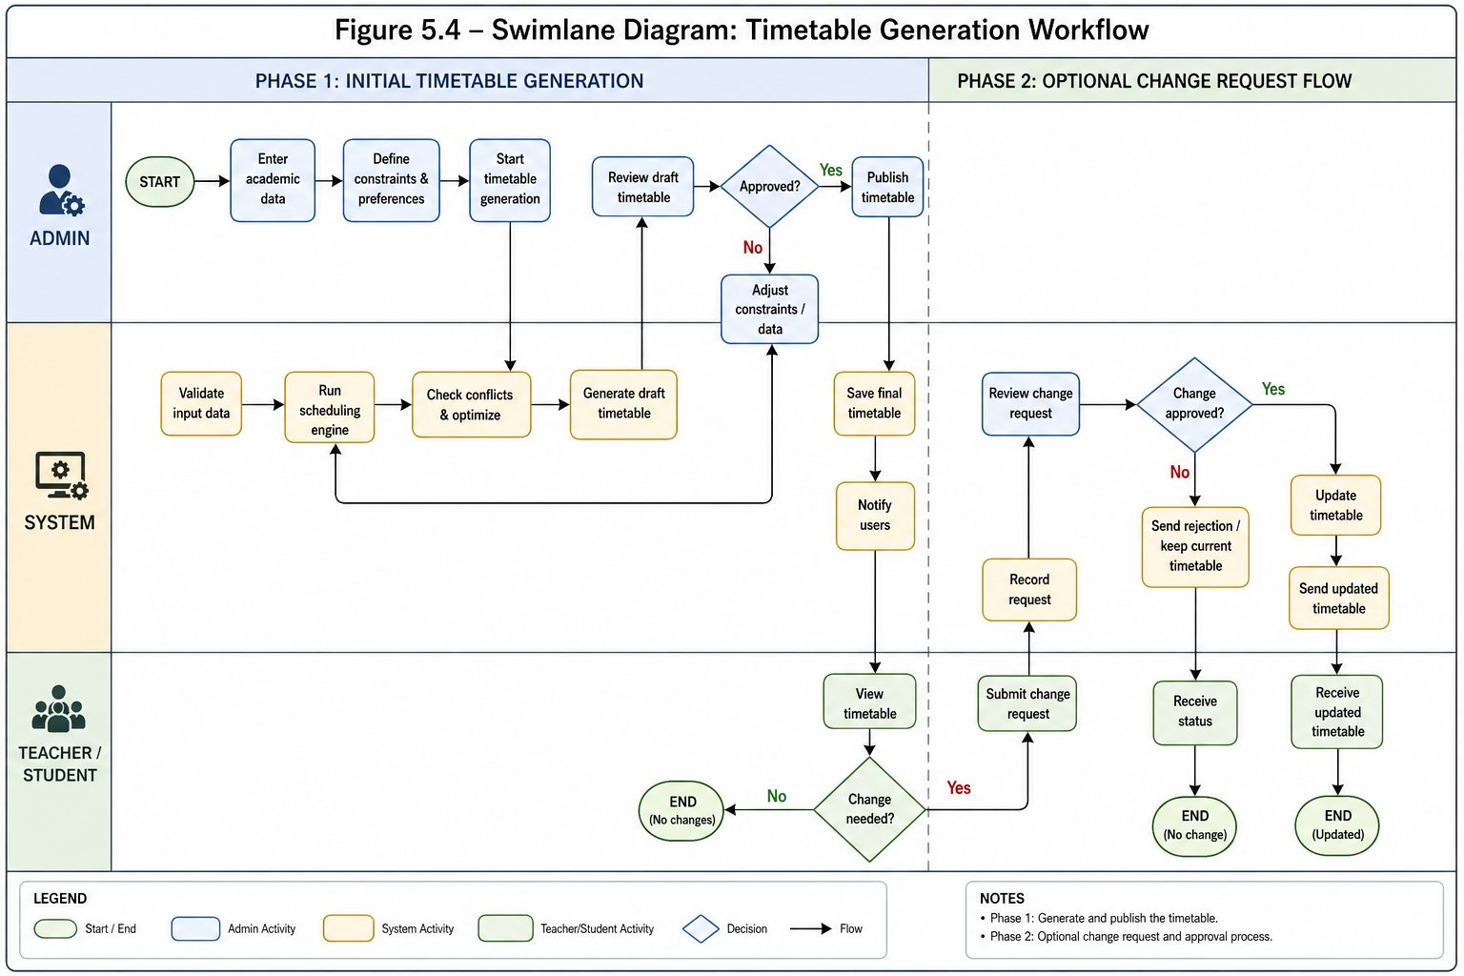
Figure 5.1 -- Class Timetabling Use Case Diagram showing UC00 and UC02--UC15 with actor associations.

5.1.2 Exam Timetabling and System Administration Use Case Diagram
This diagram covers the Exam Timetabling module (UC16--UC20) and System Administration use cases (UC21--UC22).
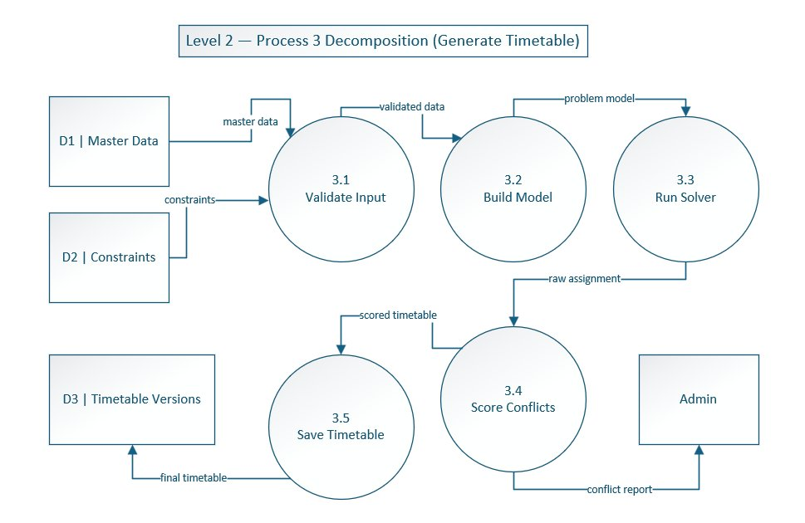
Figure 5.2 -- Exam Timetabling and System Administration Use Case Diagram showing UC16--UC22 with actor associations.

5.2 Data Flow Diagrams

5.2.1 DFD Level 0 -- Context Diagram
The Level 0 DFD treats UTOS as a single process (black box). External entities (actors) interact with the system through defined data flows.
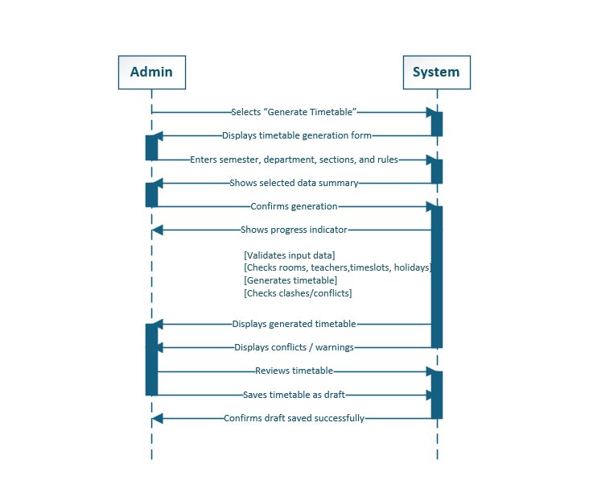
Figure 5.3 -- DFD Level 0: Context Diagram showing UTOS as a black-box system with data flows to and from all six external actor groups.

5.2.2 DFD Level 1 -- Major System Processes
Level 1 decomposes UTOS into its major functional processes, connected through the main data stores.
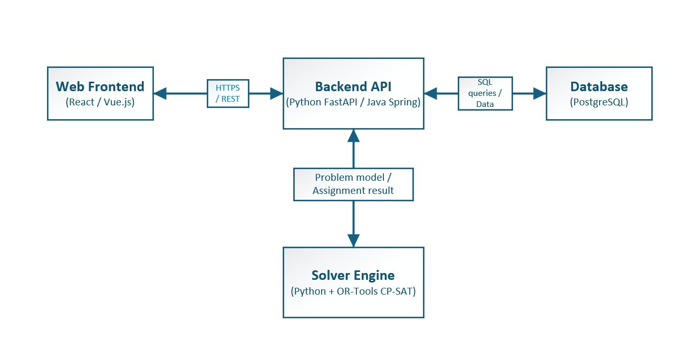
Figure 5.4 -- DFD Level 1: Major system processes and data stores.

5.2.3 DFD Level 2 -- Generate Timetable Decomposition
Level 2 decomposes the Generate Timetable process into its five sub-processes: data validation, constraint model building, solver execution, quality scoring, and result saving.
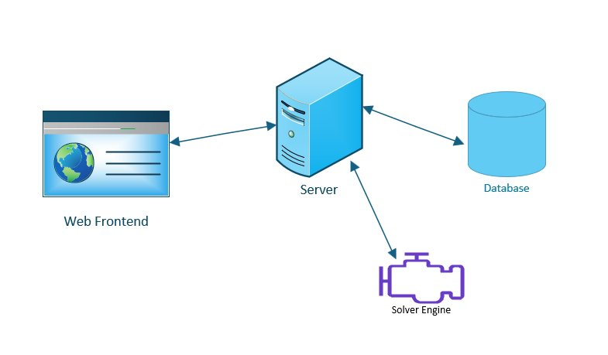
Figure 5.5 -- DFD Level 2: Generate Timetable decomposition.

5.3 Swimlane Diagram -- Class Timetabling Workflow
The swimlane diagram separates responsibilities among the four primary participants: Timetable Administrator, Department Coordinator, System (backend/solver), and Teacher/Student.
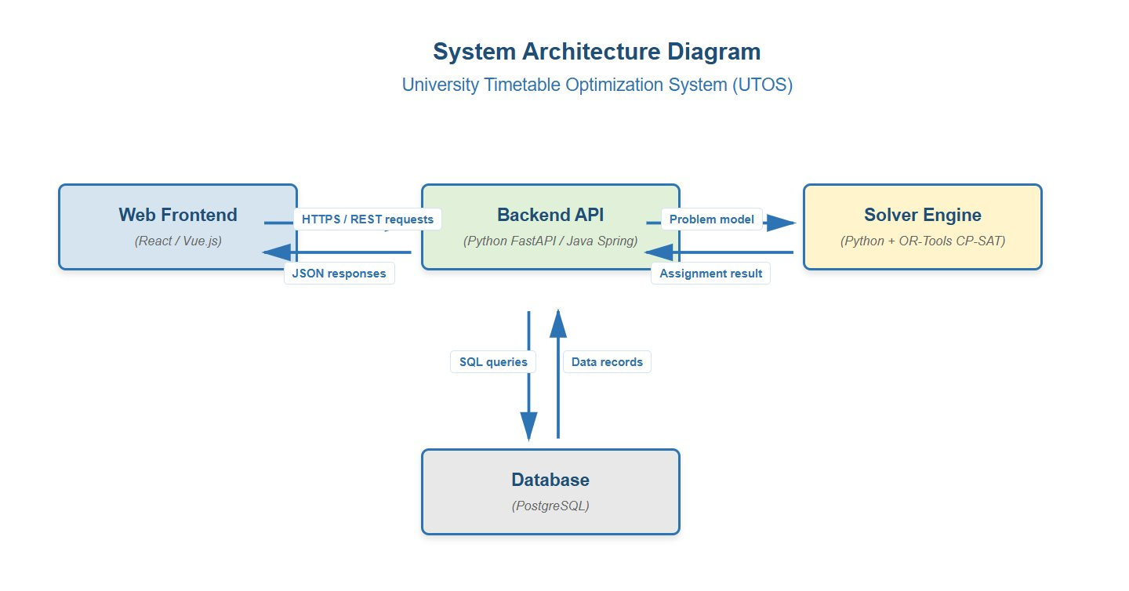
Figure 5.6 -- Swimlane Diagram showing the complete class timetabling workflow from master data entry through generation, review, locking, approval, publication, and the optional change-request branch.

5.4 Sequence Diagram -- Generate Class Timetable
The system sequence diagram for UC05 shows the interaction between the Timetable Administrator, the UTOS frontend, the backend API, the solver engine, and the database during a generation request.
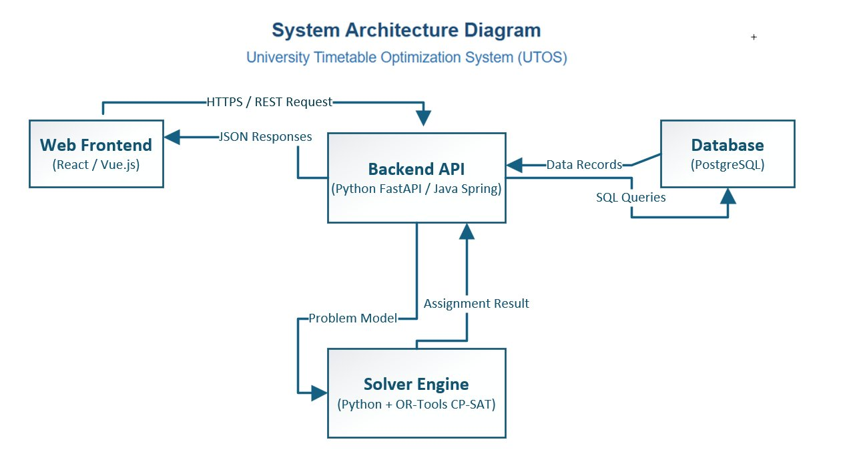
Figure 5.7 -- System Sequence Diagram for UC05 (Generate Class Timetable) showing the asynchronous generation flow.

5.5 Entity-Relationship Model
The ERD covers both the class timetabling and exam timetabling modules. Core entities from the SRS are included:
- Identity and Access: User, Role.
- Organization: University (implicit root), Faculty, Department, Batch, Section, Student.
- Resources: Building, Room, Teacher, Timeslot.
- Class Scheduling: Course, AcademicTerm, AcademicCalendar, Holiday, Constraint, Preference, TimetableVersion, TimetableEntry.
- Change and Audit: ChangeRequest, AuditLog.
- Versioning: TimetableVersion, VersionDiff.
- Communication: Notification, NotificationUser.
- Exam Module: ExamCourse, ExamSession, InvigilationAssignment, DistanceGraph.


Figure 5.8 -- Entity-Relationship Diagram showing the full-scope model including TimetableVersion, Notification, AuditLog, Faculty, Department, Batch, Student, ExamCourse, ExamSession, and InvigilationAssignment entities.

5.6 System Architecture
UTOS is built as a four-layer web application designed with a swappable solver interface.
Layer | Component | Technology (v1.0) | Future Consideration
Presentation | Web Frontend | Vanilla JS/CSS (no build step) | Framework migration if needed for scale
Application | Backend API | Python stdlib (ThreadingHTTPServer) | ASGI framework for async support
Data | Database | SQLite | PostgreSQL for 1000+ concurrent users
Computation | Solver Engine | Custom BFS-based scheduler | OR-Tools CP-SAT (planned increment 9)
Infrastructure | Background Jobs | Synchronous (MVP) | Redis queue for non-blocking generation

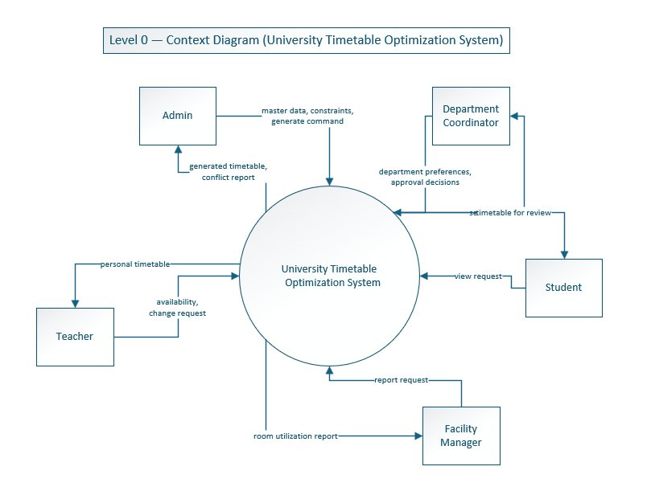
Figure 5.9 -- System Architecture Diagram showing the four-layer UTOS architecture: Web Frontend, Backend API, Database, and Solver Engine.

6. UI Evidence and Implementation Screens
The screenshots in this section provide evidence that the major real use cases already have interface support in the current or prototype implementation.

6.1 Authentication and Role-Based Navigation (UC00, UC21)
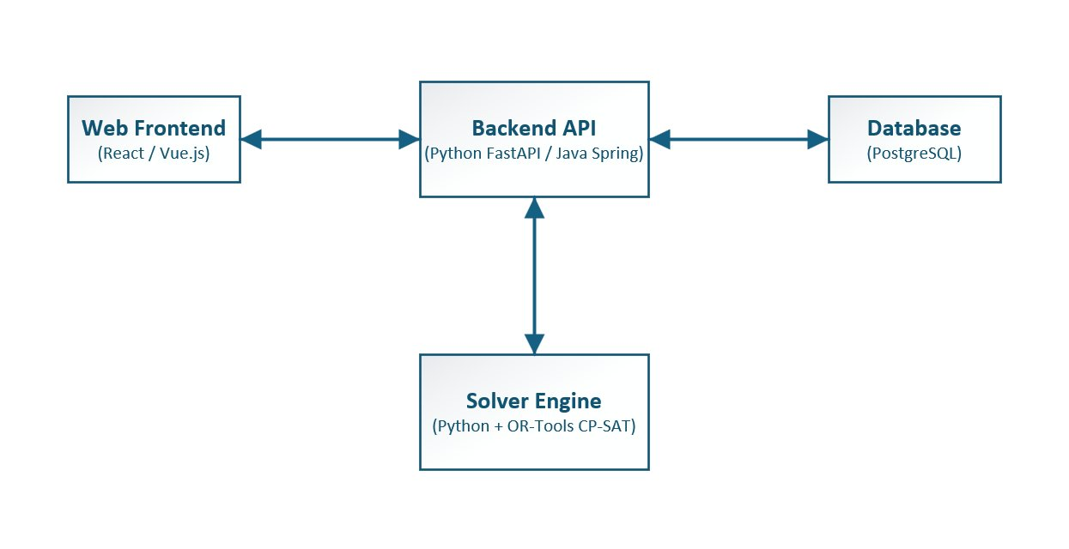
Figure 6.1 -- Role-selection login screen for UTOS. The single-page design presents a role dropdown above the credential fields, supporting the dual login method described in FR-00.1 and FR-00.2.


Figure 6.2 -- Role-specific sidebar navigation for five user roles: Facility Manager, Student, Teacher, Department Coordinator, and Timetable Manager.

6.2 Schedule Control Center (UC05, UC06)
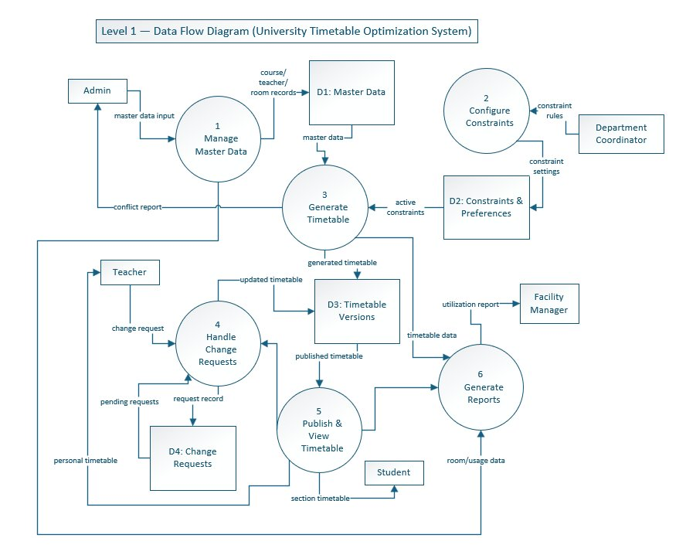
Figure 6.3 -- Schedule Control Center dashboard before generation. Status cards show courses configured, rooms available, and active sections. The Generate Draft button initiates UC05.


Figure 6.4 -- Empty timetable grid state before generation. The horizontal time-slot column structure and vertical day layout match the NFR-09a/b usability requirements.

6.3 Draft Review with Conflicts and Locks (UC06, UC07)

Figure 6.5 -- Draft review mode showing locked entries (solid padlock icons), mutable draft entries (dashed outlines), and conflict highlighting. Red conflict cards below the grid correspond to FR-05.2.

6.4 Master Data Management (UC03, UC16)

Figure 6.6 -- Master Data: Teachers Management screen. The interface supports add, update, delete, search, and filter operations (FR-02.1).


Figure 6.7 -- Master Data: Rooms Management screen. Room capacity, type, building, floor, and availability status are shown. Supports UC03 and UC16 as described in FR-02.2 and FR-15.1 to FR-15.4.

6.5 Change Request Workflow (UC08, UC09)

Figure 6.8 -- Change Request Form. The form includes Subject, Request Summary, Reason (optional), and Attach Document (optional file upload) fields.


Figure 6.9 -- Change Request Management review modal with current and proposed schedule, conflict check indicator, and Approve/Reject controls. Implements UC09 (FR-10.2, FR-10.3).

6.6 Operational Reports (UC22)

Figure 6.10 -- Room Utilization Report. Shows average occupancy statistics, a bar chart, room heatmap, and per-room detail table with export and print actions (FR-21.1).


Figure 6.11 -- Teacher Load Report. Per-teacher load bars are color-coded (green = normal, amber = heavy, red = overloaded) (FR-21.2).

6.7 Publish Final Confirmation (UC11)

Figure 6.12 -- Publish Final Confirmation screen. Step-progress indicator, timetable details panel, conflict status (100% clear), and Confirm and Publish Now button with irreversible-action warning (FR-08.1, FR-08.4).

7. Traceability Matrix
The following table links each major use case to the SRS functional requirement groups it satisfies. Use cases with expanded narratives in Section 4.4 are marked with an asterisk (*).

Use Case | Module | SRS Requirement Groups | Expanded in Section 4.4
UC00 -- Authenticate and Login* | System-wide | FR-00.1 to FR-00.6c | Yes
UC01 -- Maintain Organization Hierarchy | System-wide | FR-00.6a to FR-00.6d | No
UC02 -- Maintain Academic Calendar | Class Timetabling | FR-01.1 to FR-01.5 | No
UC03 -- Manage Master Data | Class Timetabling | FR-02.1 to FR-02.6b | No
UC04 -- Define Constraints and Preferences | Class Timetabling | FR-03.1 to FR-03.15 | No
UC05 -- Generate Class Timetable* | Class Timetabling | FR-04.1 to FR-04.7c, FR-00.9 | Yes
UC06 -- Review Timetable Quality* | Class Timetabling | FR-05.1 to FR-05.5 | Yes
UC07 -- Manually Adjust and Lock Timetable* | Class Timetabling | FR-06.1 to FR-06.4, FR-07.1 to FR-07.3 | Yes
UC08 -- Submit Change Request* | Class Timetabling | FR-10.1, FR-10.1a, FR-00.10 | Yes
UC09 -- Approve or Reject Change Request* | Class Timetabling | FR-10.2, FR-10.3, FR-07.1 | Yes
UC10 -- Re-optimize Timetable | Class Timetabling | FR-07.1 to FR-07.3 | No
UC11 -- Publish Timetable* | Class Timetabling | FR-08.1 to FR-08.4b, FR-00.8 | Yes
UC12 -- View Personal or Section Timetable | Class Timetabling | FR-09.1 to FR-09.3 | No
UC13 -- Export Timetable | System-wide | FR-00.1 to FR-00.5b (Export group) | No
UC14 -- Manage Notifications | System-wide | FR-00.6 to FR-00.14 | No
UC15 -- Compare Timetable Versions | System-wide | FR-00.15 to FR-00.19 | No
UC16 -- Manage Exam Rooms | Exam Timetabling | FR-15.1 to FR-15.4 | No
UC17 -- Manage Student Hierarchy | Exam Timetabling | FR-16.1 to FR-16.4 | No
UC18 -- Manage Exam Courses | Exam Timetabling | FR-17.1 to FR-17.3 | No
UC19 -- Schedule Exams* | Exam Timetabling | FR-18.1 to FR-18.8, FR-19.1 to FR-19.5 | Yes
UC20 -- View Exam Schedule and Invigilation Duties | Exam Timetabling | FR-19.1 to FR-19.5 | No
UC21 -- Manage Users and Roles | Administration | FR-20.1 to FR-20.8 | No
UC22 -- View System Reports and Audit Logs* | Administration | FR-21.1 to FR-21.8, NFR-07 | Yes

8. Conclusion
This document presents UTOS as a full-scope university timetable optimization and management platform. The key contributions of this version include:
- Full alignment with SRS v1.0 Full Scope, including the exam timetabling module, system-wide features (notifications, versioning, export, audit logs), and the complete role set.
- A comprehensive use case analysis following the teacher-provided Analysis Models guidance, with high-level use cases for all twenty-three use cases and fully expanded narratives (essential + real dual flows) for eight selected use cases.
- System modeling diagrams (DFD Level 0/1/2, swimlane, sequence, ERD, and architecture) aligned with the SRS.
- UI screenshot evidence demonstrating interface support for login, dashboard, timetable generation, draft review, master data management, change requests, reports, and publishing.
- A traceability matrix linking all use cases to the SRS requirement groups they satisfy.

8.1 Document Completeness Checklist
Deliverable | Included | Location
High-level use cases (all 23) | Yes | Section 4.3
Expanded use cases with dual essential/real flows | Yes | Section 4.4 (UC00, UC05--UC09, UC11, UC19, UC22)
Essential use cases (abstract, technology-free) | Yes | Section 4.4, each expanded UC
Real use cases (tied to UTOS UI screenshots) | Yes | Section 4.4, each expanded UC
Typical Course of Events (Actor Action / System Response tables) | Yes | Section 4.4
Alternative courses for each expanded use case | Yes | Section 4.4
Class Timetabling Use Case Diagram | Yes | Figure 5.1
Exam Timetabling and System Administration Use Case Diagram | Yes | Figure 5.2
DFD Level 0 -- Context Diagram | Yes | Figure 5.3
DFD Level 1 -- Major Processes | Yes | Figure 5.4
DFD Level 2 -- Generate Timetable Decomposition | Yes | Figure 5.5
Swimlane Diagram -- Class Timetabling Workflow | Yes | Figure 5.6
System Sequence Diagram -- Generate Class Timetable | Yes | Figure 5.7
ERD / Domain Model | Yes | Figure 5.8
System Architecture Diagram | Yes | Figure 5.9
UI Screenshots with captions (12 figures) | Yes | Section 6
SRS Alignment and Requirements Summary | Yes | Section 3
Traceability Matrix (UC to SRS requirements) | Yes | Section 7
Process Model with increments | Yes | Section 2

References
- SRS_v1.0_Full_Scope.md -- Full-scope Software Requirements Specification for UTOS (primary source of truth for all requirements).
- 04_Analysis-Models.ppt -- Teacher-provided Software Engineering Analysis Models guidance covering use case types, expanded use cases, essential vs. real use cases, actor-goal identification, use case diagrams, DFDs, and domain modeling.
- UTOS_Full_Scope_Use_Case_Analysis_with_UI.docx -- Earlier use case analysis document used as a starting baseline for this revision.
- User-supplied screenshots and diagrams -- UI evidence, ERD, DFDs, swimlane, sequence, process model, and architecture figures provided with the project files.
- Larman, C. (2004). Applying UML and Patterns: An Introduction to Object-Oriented Analysis and Design and Iterative Development. Prentice Hall.
- Jacobson, I. et al. (1992). Object-Oriented Software Engineering: A Use Case Driven Approach. Addison-Wesley.
- Bettinelli, A. et al. (2015). An overview of curriculum-based course timetabling. TOP.
- Google OR-Tools CP-SAT Documentation -- Reference for future solver upgrade.

